Exercise 3a
Create a prototype with familiar and unfamiliar navigation elements. Evaluate ease of use with different user groups using proto.io

Aim:
The aim is to develop a prototype incorporating both familiar and novel navigation
elements and assess usability among diverse user groups using Proto.io.

PROTOTYPE DESCRIPTION
A mobile application prototype was designed using Proto.io with four main screens:
• Home Screen
• Profile Screen
• Details Screen
• Gallery Screen
The prototype includes both traditional (familiar) and advanced (unfamiliar) navigation techniques.

1. Home Screen
Description:
The Home screen acts as the main entry point of the application. It contains:
• Header (Home)
• “Go to Profile” Button

Familiar Navigation:
• Button (Go to Profile):
Users click the button to navigate to the Profile screen.
This is a standard and widely used navigation method.

Unfamiliar Navigation:
• Swipe Left Gesture:
Users can swipe left on the Home screen to navigate to the Gallery screen.
This is not visibly indicated and requires user discovery.


2. Profile Screen
Description:
The Profile screen displays user details such as:
• Profile Image
• User Name (Mary)

Familiar Navigation:
• Tap Interaction:
Basic tapping is used for navigation between screens.

Unfamiliar Navigation:
• Double Tap on Name (Mary):
Users must double tap the name “Mary” to navigate to the Details screen.
This interaction is hidden and not commonly expected by users.
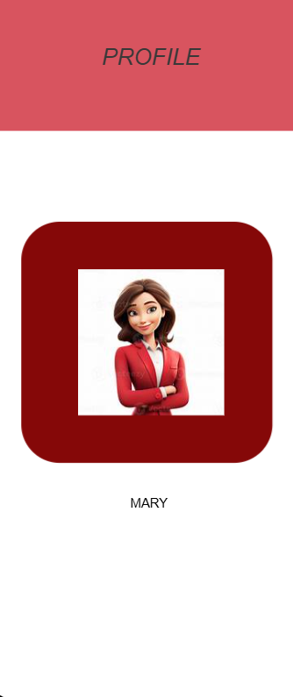

3. Details Screen
Description:
The Details screen provides additional information such as:
• Educational Qualification
• Skills
• Achievements

Familiar Navigation:
• No standard visible buttons are used.

Unfamiliar Navigation:
• Accessed only through double tap interaction from Profile screen.
This makes it a non-obvious navigation flow.



4. Gallery Screen
Description:
The Gallery screen displays images such as:
• Scenic pictures
• Travel images

Familiar Navigation:
• No visible buttons are used for navigation.

Unfamiliar Navigation:
• Swipe Right Gesture:
Users swipe right to return to the Home screen.
This gesture-based navigation is hidden and requires user learning.



